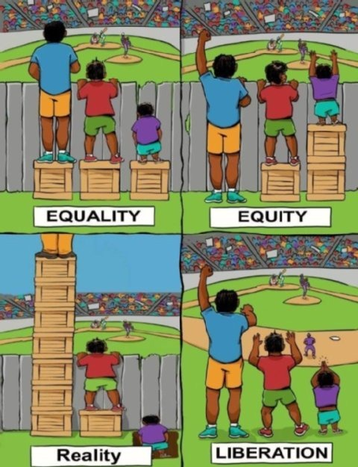
Quelle: https://cf.girlsaskguys.com/q3600793/6bd4a603-7db5-4ff9-b249-992ede8a34dc.jpg

